RESOLUTION NO.__________

RE: CERTIFICATE OF APPROPRIATENESS UNDER THE
PROVISIONS OF THE ACT OF THE PENNSYLVANIA
LEGISLATURE 1961, JUNE 13, P.L. 282 (53
SECTION 8004) AND BETHLEHEM ORDINANCE NO.
3952 AS AMENDED.

WHEREAS, it is proposed remove the existing building “fabric” and install new aluminum storefront material at 129 W 4th Street.

NOW, THEREFORE, BE IT RESOLVED by the Council of the City of Bethlehem that a Certificate of Appropriateness is hereby granted for the work.

Sponsored by: (s)

(s)

ADOPTED BY COUNCIL THIS DAY OF

(s)
President of Council

ATTEST:

(s)
City Clerk

HISTORIC CONSERVATION COMMISSION

CASE # 594– It is proposed to remove the existing building “fabric” and install new aluminum storefront material at 129 W 4th Street
OWNER/APPLICANT: Joe Hanna/ NYC Village Pizza

The Commission upon motion by Mr. Roeder seconded by Mr. Cornish adopted the proposal that City Council issue a Certificate of Appropriateness for the proposed work described herein:
- The proposal to remove the existing building “fabric” and install new aluminum storefront material at 129 W 4th Street was represented by Mustafa Okumus.

- The existing historic aluminum framing and marble clad knee wall were removed and pilasters and entablature covered with aluminum without HCC review or approval.

- The aluminum covering the pilasters and entablature must be removed and the existing pilasters and entablature repaired and restored to historic appearance.

- The new black aluminum storefront framing will be removed at the bottom and a new knee wall will be installed.

- The new knee wall will be clad with 12x12 very dark green/black marble backed with appropriate tile substrate such as concrete board.

- Grates similar to the historic will be replicated and reinstalled in the storefront kneewall in the historic location.

- The black aluminum storefront framing may be retained above the new kneewall, however the center entrance must be recessed at a minimum 3’ from the front of the building and be wide enough to accommodate the latch side clearances required by the Building Code for accessibility.

- A drawing of storefront and a marble sample must be submitted for review and approval.

- The motion to approve the proposal was unanimously approved.

- The Commission upon a second motion by Mr. Evans seconded by Ms. Starbuck tabled the proposed awning. The HCC requested drawings showing the entire building listing the length, size and attachment of awning. The awning will only be placed on the front façade and not on the side, west façade. The motion to table the proposal was unanimously approved.
CU: cu
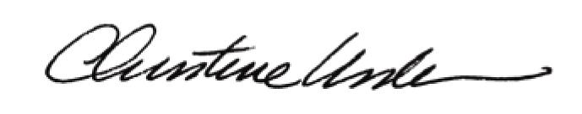

By:

Date of Meeting: September 19, 2016 Title: Historic Officer

